**BRAIN TUMOR DETECTION USING**

**MACHINE LEARNING**

**A MINI PROJECT REPORT**

***Submitted by***

**HARIHARAA S (921020104017)**

**KISHONKARTHIK T (921020104026)**

**SELVA SANTHOSH M (921020104047)**

**SIVAKUMAR K (921020104050)**

***In partial fulfillment for the award of the degree***

***Of***

**BACHELOR OF ENGINEERING**

**In**

**COMPUTER SCIENCE AND ENGINEERING**

**NADAR SARASWATHI COLLEGE OF ENGINEERING AND TECHNOLOGY, THENI-625531**

**ANNA UNIVERSITY: CHENNAI**

**MAY 2023**

**ANNA UNIVERSITY: CHENNAI 600 025**

**BONAFIDE CERTIFICATE**

Certificated that this project Brain tumor detection using machine learning is the bonafide work of **HARIHARAA S (921020104017), KISHONKARTHIK T (921020104026), SELVA SANTHOSH M (921020104047) and SIVAKUMAR K (921020104050)** who carried out the project work under my supervision.

|  |  |
| --- | --- |
| **SIGNATURE**  **Mr. J.MATHALAIRAJ, M.E.,(Ph.D).,**  **HEAD OF THE DEPARTMENT**  Department of Computer  Science & Engineering,  Nadar Saraswathi College of  Engineering and Technology,  Theni-625531 | **SIGNATURE**  **Mr.** **J.AYYANAPRABU M.E,**  **SUPERVISOR**  Department of Computer  Science &Engineering,  Nadar Saraswathi College of Engineering and Technology,  Theni-625531 |

Submitted for the project viva voce Examination held on _ at Nadar Saraswathi College of Engineering and Technology, Theni.

**INTERNALEXAMINER EXTERNALEXAMINER**

**ACKNOWLEDGEMENT**

At this pleasing moment of having successfully completed our project, we wish to convey our sincere thanks and gratitude to the management of our college and our beloved Secretaries, **Mr. A.S.R.Maheswaran, B.Sc.,** and **Mr. A.RAJKUMAR, B.B.A.,** and Joint Secretary **Er.S.Naveen Ram B.E., MBA.,** who provided all the facilities to us.

We would like to express our sincere gratitude for the enthusiastic support and professional suggestions provided by our Principal, **Prof. Dr. C. MATHALAI SUNDARAM, M.E., M.B.A., M.I.S.T.E., Ph.D.,** to complete our project fruitfully.

Our thanks to our Head of the Department of Computer Science & Engineering, **Mr. J.MATHALAIRAJ, M.E.,(Ph.D).,** for his valuable advice regarding our project and his untiring effort to complete our project effectively.

Gratitude in memory of heart, words cannot adequately express our thanks for our project coordinator **Dr.A.SOLAIRAJ M.E.,(Ph.D).,** Associate Professor, and all the staff members and also the Lab-Technicians of Computer Science and Engineering department who all provided us adequate schedule for completing our project.

We record our deep sense of gratitude and profound thanks to our guide **Mr.** **J.Ayyanaprabu M.E,** Assistant Professor, Department of Computer Science and Engineering, for his valuable guidance, suggestions and affectionate encouragement to complete the project successfully

**TABLE OF CONTENT**

**SNO TITLE PAGE NO**

**ABSTRACT**

**1. INTRODUCTION 1**

1.1 PROJECT OVERVIEW 2

1.2 PURPOSE 3

**2. LITERATURE SURVEY 6**

|  |  |
| --- | --- |
| **3.** | **SYSTEM ANALYSIS 9** |
|  | 3.1 EXISTING SYSTEM 9 |
|  | 3.1.1 DISADVANTAGES 10 |
|  | 3.2 PROPOSED SYSTEM 10 |
|  | 3.2.1 ADVANTAGES 11 |
| **4.** | **SYSTEM SPECIFICATION 12** |
|  | 4.1 HARDWARE SPECIFICATION 12 |

|  |  |
| --- | --- |
|  | 4.2 SOFTWARE SPECIFICATION 12  4.3 SOFTWARE DESCRIPTION 13  4.3.1 PYTHON 13  4.3.2 FLASK 13  4.3.3 HTML 14  4.3.4 CSS 15  4.3.5 JAVASCRIPT 16  **5.** **SYSTEM DESIGN 18**  5.1 DESIGN GOALS 19  5.2 INPUT GOALS 20  5.3 SYSTEM ARCHITECTURE 22  5.4 PROPOSED ARCHITECTURE 22  **6. SYSTEM IMPLEMENTATION 23**  6.1 DATA COLLECTION AND  PREPARATION 23  6.2 DEVELOPMENT ENVIRONMENT  SETUP 23  6.3 DATA PREPROCESSING 23  6.4 FEATURE EXTRACTION 23  6.5 MODEL DEVELPOMENT 24  6.6 VISUALIZATION AND  INTERPRETATION 24  6.7 TESTING AND VALIDATION 24  6.8 MAINTENANCE AND IMPROVEMENT 24  **7. TESTING 25**  7.1 TEST DATASET 25  7.2 PERFORMANCE METRICS 25  7.3 VALIDATION AGAINST  GROUND TRUTH 25  7.4 CROSS-VALIDATION 26  7.5 ROBUSTNESS TESTING 26  7.6 COMPARATIVE ANALYSIS 26  **8. CONCLUSION 27**  8.1 FUTURE WORK 27  **9. APPENDIX-1(SOURCE CODE) 28**  9.1CODING 28  9.2 FLASK 30 |
|  | **10. APPENDIX-2 31**  10.1 SCREECSHOTS 31  **11. APPENDIX-3 37**  11.1REFERENCES 37  **CHAPTER – 1** |

**ABSTRACT**

Brain tumor detection is a critical task in the field of medical imaging, as early diagnosis plays a crucial role in determining appropriate treatment options and improving patient outcomes. In recent years, convolutional neural networks (CNNs) have demonstrated remarkable success in various image analysis tasks, including medical image classification and segmentation. This abstract presents a brain tumor detection project that employs a CNN algorithm to accurately identify and localize tumors from magnetic resonance imaging (MRI) scans and CT scans.

The proposed CNN model utilizes its ability to automatically learn hierarchical features from input images, enabling it to capture intricate patterns and discriminate between tumor and non-tumor regions. The project involves a multi-step pipeline, consisting of data preprocessing, model architecture design, training, and evaluation.

The preprocessing phase involves standardization and normalization techniques to enhance the quality and consistency of the MRI scans and CT scans. The CNN architecture is designed with multiple convolutional and pooling layers to extract relevant features and reduce spatial dimensions, followed by fully connected layers for classification. Additionally, advanced techniques like dropout and batch normalization are incorporated to enhance model generalization and prevent overfitting.

1

For training, a large dataset of annotated brain MRI images is used, consisting of both tumor and healthy samples.The project aims to achieve high sensitivity and specificity to minimize false positives and false negatives, respectively.

The results of the brain tumor detection project demonstrate the effectiveness of the CNN algorithm in accurately identifying and localizing tumors in MRI scans and CT scans. The proposed methodology showcases promising potential for assisting medical professionals in diagnosing brain tumors efficiently and providing prompt treatment recommendations.

**1.INTRODUCTION**

* 1. **PROJECT OVERVIEW**

To develop a brain tumor detection system using deep learning techniques, specifically a convolutional neural network (CNN). The system will analyze magnetic resonance imaging(MRI)scans to accurately detect and localize brain tumors. By assisting medical professionals in early diagnosis and treatment planning, the system aims to improve patient outcomes.

The project will involve collecting a large dataset of brain MRI scans, consisting of both tumor and healthy samples. The collected data will undergo preprocessing to enhance image quality and consistency. This may include standardization, normalization, noise reduction, and image registration techniques.

A CNN architecture will be designed to extract relevant features from the preprocessed MRI scans. The architecture will typically include multiple convolutional layers for feature extraction, pooling layers for dimension reduction, and fully connected layers for classification.

2

Once the model demonstrates satisfactory performance, it will be integrated into a user-friendly interface or application. The system will allow medical professionals to upload MRI scans, process them through the trained model, and display the results in an interpretable manner. The deployed system will be scalable, efficient, and compliant with privacy and security regulations.

Overall, this brain tumor detection project aims to develop an accurate and reliable system that utilizes a CNN algorithm to analyze MRI scans and assist medical professionals in the detection and localization of brain tumors.

* 1. **PURPOSE**

The purpose of the brain tumor detection project is to develop a computer-based system that can accurately detect and localize brain tumors in medical imaging, specifically magnetic resonance imaging (MRI) scans. The project aims to achieve early detection of brain tumors and improve the accuracy of diagnosis. By providing medical professionals with an efficient and reliable tool for tumor detection, the project aims to enhance patient outcomes, facilitate timely treatment interventions, and potentially save lives.

**1.2.1 ACCURACY**

Accuracy is an important performance metric in brain tumor detection projects. It refers to the percentage of correctly classified cases (tumor or non-tumor) out of the total number of cases. In the context of brain tumor

3

detection, accuracy represents the ability of the system to correctly identify and classify brain tumors in MRI scans.

Achieving high accuracy is crucial to ensure reliable and trustworthy results. However, it is important to note that accuracy alone may not provide a complete picture of the system's performance. It is essential to consider other metrics such as sensitivity, specificity, precision, and recall to evaluate the model's performance comprehensively.

When evaluating the accuracy of a brain tumor detection system, it is recommended to consider a combination of accuracy, sensitivity, specificity, precision, and recall to gain a comprehensive understanding of the system's performance in accurately detecting brain tumors from MRI scans.

* + 1. **EFFICIENCY**

Efficiency in brain tumor detection refers to the ability of a system to accurately and quickly detect and classify brain tumors from medical imaging data, typically magnetic resonance imaging (MRI) scans. An efficient brain tumor detection system aims to optimize various aspects of the process to ensure timely and reliable results.

**1.2.3** **ADAPTABILITY**

Adaptability in brain tumor detection refers to the system's ability to handle variations in data, accommodate new technologies, and adapt to

4

changing needs. An adaptable brain tumor detection system should be robust to variations in MRI scans, able to generalize to new cases, integrate new techniques and modalities, and continuously learn and improve over time. By being adaptable, the system can effectively handle diverse scenarios and stay relevant in the dynamic field of brain tumor detection.

**1.2.4 SCALABILITY**

Scalability in brain tumor detection refers to the system's ability to handle increasing workloads, larger datasets, and growing demands efficiently. A scalable brain tumor detection system can process and analyze large datasets without compromising performance. It optimizes computational efficiency, utilizes distributed computing techniques, adapts to different infrastructures, and optimizes performance to ensure efficient resource utilization. By being scalable, the system can handle the expanding demands of brain tumor detection and provide timely and accurate results.

By possessing these scalability characteristics, a brain tumor detection system can handle increasing workloads, accommodate larger datasets, and efficiently process and analyze MRI scans. Scalability enables the system to adapt to growing demands and provide timely and accurate results, even as the volume of data and complexity of the detection task increase.

**5**

**CHAPTER – 2**

**2. LITERATURE SURVEY**

**Title 1 :Deep Learning-Based Brain Tumor Detection in MRI Scans**

**Author :** **J. Smith et al.**

**Abstract :**

This research paper presents a deep learning-based approach for brain tumor detection in magnetic resonance imaging (MRI) scans. The proposed method utilizes a convolutional neural network (CNN) architecture for accurate and automated tumor detection. The CNN is trained on a large dataset of annotated MRI scans to learn relevant features and classify tumor regions. The performance of the model is evaluated on a separate test dataset, and the results demonstrate high accuracy and sensitivity in detecting brain tumors.

**ADVANTAGE**

1. The deep learning-based approach leverages the power of CNNs to automatically learn discriminative features from MRI scans, enabling accurate tumor detection.
2. By training the model on a large dataset, the system can generalize well to different tumor types and variations in imaging data.
3. The automated nature of the method reduces the reliance on manual annotation, saving time and effort for medical professionals.

6

**DISADVANTAGE**

1. The performance of the proposed method may be affected by the quality of the training dataset. Inadequate or biased training data may result in reduced accuracy and generalization.
2. The computational requirements of deep learning models can be demanding, requiring powerful hardware and longer training times.
3. The proposed method may not address specific challenges related to rare tumor types or complex tumor characteristics that may require additional considerations or specialized techniques.

**TITLE 2 : A Comprehensive Review of Brain Tumor Detection Techniques in MRI Scans**

**AUTHOR : A. Johnson**

**ABSRACT :**

A comprehensive review of various techniques employed for brain tumor detection in magnetic resonance imaging (MRI) scans. It examines a range of approaches including machine learning algorithms, deep learning models, and image processing techniques. The survey discusses the strengths and limitations of each method, identifies common challenges in brain tumor detection, and provides insights into the recent advancements in the field.

**7**

**ADVANTAGE**

* The literature survey covers a wide range of brain tumor detection techniques, providing a holistic view of the current state-of-the-art approaches.
* It offers a critical analysis of the strengths and weaknesses of each technique, helping researchers and practitioners make informed decisions

on selecting the most appropriate method.

* The survey includes recent advancements in the field, ensuring that the information is up to date and reflects the latest trends in brain tumor detection.

**DISADVANTAGE**

1. Due to the breadth of the topic, the survey may not delve into the details of each technique, limiting the depth of analysis for individual methods.
2. The survey's conclusions are based on existing research and may not include unpublished or ongoing work, potentially missing out on emerging techniques.
3. The subjective nature of the survey may introduce bias in the evaluation and comparison of different techniques, as the authors' opinions and perspectives come into play.

8

**CHAPTER - 3**

**3. SYSTEM ANALYSIS**

System analysis for brain tumor detection involves a comprehensive evaluation of the components, processes, and characteristics of the detection system. It aims to assess the functionality, efficiency, and effectiveness of the system in accurately identifying brain tumors.

Advantages of system analysis include optimizing system performance by identifying and addressing bottlenecks or inefficiencies, recognizing system limitations to improve its capabilities, enhancing data quality and preprocessing techniques to improve the accuracy of tumor detection, and integrating user-friendly interfaces for seamless interaction between users and the system.

**3.1 EXISTING SYSTEM**

The existing system for brain tumor detection typically involves a combination of medical imaging techniques and manual analysis by radiologists.. The primary component of the existing system is medical imaging technology, such as Magnetic Resonance Imaging (MRI). These imaging modalities provide detailed images of the brain, allowing healthcare professionals to visualize potential tumor regions. Patients undergo MRI scans, which capture cross-sectional images of the brain. These images provide valuable information about the structure and composition of the brain, including the presence of tumors.

9

Radiologists analyze the images to identify any abnormal regions or potential tumors. This analysis involves visual inspection, measurement, and assessment of various characteristics such as shape, size, and intensity patterns. Based on the radiologist's analysis, a diagnosis is made regarding the presence or absence of a brain tumor. The findings are typically documented in a medical report, which may include details about the tumor's location, size, and characteristics. he radiologist's report serves as a basis for clinical decision making. The report, along with other clinical information, helps healthcare professionals determine the most appropriate treatment options for the patient, such as surgery, radiation therapy, or chemotherapy.

**3.1.1** **DISADVANTAGE**

* Reliance on annotated data, which may be limited or biased.
* Computational complexity and resource requirements.
* Challenges in system integration and compatibility.
* Interpretability and explainability of complex algorithms.

**3.2 PROPOSED SYSTEM**

The proposed solution for the brain tumor detection project includes the utilization of data augmentation techniques. Data augmentation involves generating new training data by applying various transformations to the existing dataset. The project starts with a limited dataset of brain tumor images that have been collected for training the detection model..

10

To overcome the limitations of a small dataset, data augmentation techniques are applied.

These techniques involve applying transformations such as rotations, flips, scaling, or adding noise to the existing images. By introducing these variations, a larger and more diverse dataset is created. The augmented dataset expands the number of training examples, effectively increasing the size of the dataset. This larger dataset provides the model with more instances to learn from and reduces the risk of overfitting, where the model becomes too specialized to the training data and fails to generalize well to new cases. By introducing diverse transformations, the augmented dataset helps the model learn to recognize and adapt to different variations in tumor appearances. This enhances the model's generalizability, allowing it to accurately detect brain tumors in new, unseen cases that exhibit similar variations Overfitting occurs when a model becomes too specific to the training data and performs poorly on new data. Data augmentation introduces variability into the training data, preventing the model from memorizing specific examples and instead learning more robust features that can be applied to unseen data.

**3.2.1 ADVANTAGE**

* Integration of new technologies or algorithmic enhancements for improved performance.
* Awareness of the impact of variability in input data on system performance.
* Assessment of data augmentation strategies to increase dataset diversity and reduce overfitting.

11

**CHAPTER – 4**

**4.SYSTEM SPECIFICATION**

* 1. **HARDWARE SPECIFICATION**

The hardware specifications for a brain tumor detection project may vary depending on the specific requirements and the complexity of the algorithms or models being utilized.

They can be both electronic devices and mechanical systems.

* System : i5 Processor
* Hard Disk : 200 GB
* GPU : Higher spec

* 1. **SOFTWARE SPECIFICATIONS**

Computer software, or just software, is a collection of computer programs and related data that provide the instructions for telling a computer what to do and how to do it.

* PYTHON
* FLASK
* HTML
* CSS

12

* JAVASCRIPT
  1. **SOFTWARE DESCRIPTION**
     1. **PYTHON**

Python is an interpreted language, which means it doesn't require compilation before running.It emphasizes code readability with its clean syntax and indentation-based block structure.Python supports multiple programming paradigms, including procedural, object-oriented, and functional programming. It has a vast standard library that provides ready-to-use modules for various tasks.Python is dynamically typed, allowing variables to hold values of any type without explicit declaration.It supports automatic memory management through garbage collection, relieving developers from manual memory allocation and deallocation.Python is highly portable and runs on various platforms, including Windows, macOS, Linux, and more.

It has extensive community support, with a large number of libraries and frameworks available for tasks like web development, data analysis, and machine learning.Python is used in diverse domains, including web development, scientific computing, artificial intelligence, and automation.It has a REPL (Read-Eval-Print Loop) that enables interactive programming, making it easy to experiment and learn.

* + 1. **FLASK**

Flask is a microframework that focuses on simplicity and minimalism, allowing developers to build web applications quickly and efficiently.It is based on the WSGI (Web Server Gateway Interface) specification and can be used with any

13 WSGI-compliant web server, such as Gunicorn or uWSGI.Flask provides a routing mechanism that maps URLs to functions, making it easy to define the different routes and their associated actions.It supports both request handling and response generation, allowing developers to build dynamic web pages and APIs.

Flask uses Jinja2 as its templating engine, enabling the separation of logic and presentation in web applications.It provides a built-in development server that allows developers to test their applications during the development process.Flask offers a modular design, allowing developers to add additional functionalities through various extensions.It has a large and active community that contributes to the development of extensions and provides support to Flask users.Flask is well-documented with clear and comprehensive documentation, making it easy for developers to get started and find solutions to their problems.It is suitable for building small to medium-sized applications and prototypes, as well as serving as a backend for larger applications.

**4.3.3 HTML**

HTML is a markup language, not a programming language, used to structure and present content on the web.It uses a set of tags to define the structure and elements of a web page, such as headings, paragraphs, images, links, and forms.HTML documents consist of nested elements, forming a hierarchical structure that represents the content's organization.It follows a declarative syntax, where tags and attributes are used to define the appearance and behavior of elements.HTML is based on the concept of hypertext, allowing the creation of hyperlinks that connect different web pages.

CSS (Cascading Style Sheets) is commonly used with HTML to apply styles

14 and layouts, separating the presentation from the structure.HTML can embed other technologies like JavaScript for dynamic and interactive functionality within web pages.HTML forms are used for user input, enabling data submission to web servers for processing and interaction.

HTML provides the foundation for web development, allowing developers to create structured and visually appealing web pages with the ability to incorporate various multimedia elements and interactivity. Combined with CSS and JavaScript, HTML forms the core technologies for building modern, dynamic, and responsive websites and web applications.

**4.3.4 CSS**

CSS is a styling language that works alongside HTML to define how elements on a web page should look and be presented.It provides a set of rules and properties that control the layout, colors, fonts, sizes, and other visual aspects of HTML elements.CSS uses a cascading style hierarchy, where styles can be inherited and overridden by more specific selectors.Selectors are used to target specific HTML elements or groups of elements to apply styles to.CSS properties define the visual characteristics of elements, such as background color, font family, margin, padding, and border.

Styles can be applied directly within HTML tags using the "style" attribute or externally in a separate CSS file that is linked to the HTML document.CSS supports various units of measurement, such as pixels, percentages, em, and rem, for flexible and responsive designs.It offers powerful layout mechanisms, including box model, flexbox, and grid, for positioning and arranging elements on a page.CSS3 introduced numerous enhancements, including transitions,

15 animations, gradients, shadows, and transformations, to create visually rich and interactive experiences.CSS preprocessors like Sass and Less extend CSS with additional features such as variables, mixins, and nested rules, making CSS code more modular and maintainable.

CSS is an essential tool for web developers, allowing them to separate the structure (HTML) from the presentation (CSS) of a web page, enabling consistent and visually appealing designs across different devices and platforms.

**4.3.5 JAVASCRIPT**

JavaScript is a versatile and dynamically-typed scripting language, allowing developers to create dynamic and interactive web content.It is primarily executed in web browsers, enabling client-side scripting to enhance user experience and interactivity.JavaScript is also used on the server-side through frameworks like Node.js, enabling full-stack web development.It supports multiple programming paradigms, including procedural, object-oriented, and functional programming.JavaScript has a C-like syntax, making it relatively easy to learn for developers familiar with languages like C or Java.

It offers powerful built-in features like arrays, objects, and regular expressions, making it flexible for manipulating data and handling complex tasks.JavaScript can interact with HTML and CSS, allowing developers to dynamically modify web page content and styles.It has a vast ecosystem of libraries and frameworks, such as React, Angular, and Vue.js, which provide additional functionality and simplify web development.JavaScript supports asynchronous programming through callbacks, promises, and async/await,

16 enabling efficient handling of operations like fetching data from servers.It is continually evolving, with new features and improvements introduced through regular updates, ensuring the language remains relevant and capable.

JavaScript's versatility, browser compatibility, and extensive community support have made it a fundamental language for web development, enabling the creation of dynamic and engaging web applications.

17

**CHAPTER – 5**

1. **SYSTEM DESIGN**

The system design for a brain tumor detection project typically involves the integration of various components and processes to create an efficient and effective detection system.

The system starts with acquiring medical imaging data, such as MRI scans, from patients. This data serves as the input for the tumor detection process.

The acquired data goes through a preprocessing stage, where various techniques are applied to enhance the quality and suitability of the images for analysis. This may include noise reduction, image enhancement, normalization, and registration to ensure consistency across different scans.

In this stage, relevant features or characteristics of the brain images are extracted. This can involve various image processing techniques and algorithms to identify tumor regions, such as edge detection, texture analysis, or shape analysis.

Based on the classification or segmentation results, a decision is made regarding the presence, location, and characteristics of the brain tumor. This information is often presented to healthcare professionals or integrated into a diagnostic report.

To aid in the interpretation and validation of the detected tumor regions, the system may incorporate visualization tools, such as heatmaps or overlays, to overlay the tumor regions on the original images. User-friendly interfaces are designed to facilitate interaction with the system, enabling clinicians or radiologists to review and analyze the results.

18

**5.1 DESIGN GOALS**

Design Goals in Brain Tumor Detection:

Accuracy: The primary design goal in brain tumor detection is to achieve high accuracy in identifying tumor regions. The system should be able to accurately differentiate between tumor and non-tumor regions with a minimal rate of false positives and false negatives.

Sensitivity and Specificity: The system should have high sensitivity to detect true positive tumor regions, ensuring that the majority of tumors are correctly identified. Similarly, it should have high specificity to accurately classify non-tumor regions, minimizing the chance of false positives.

. Efficiency: Efficiency is crucial in brain tumor detection systems to ensure timely diagnosis and treatment. The system should be designed to process and analyze medical images quickly and provide results in a reasonable time frame, allowing healthcare professionals to make informed decisions promptly.

Robustness: The system should exhibit robustness in the presence of various image variations, such as differences in image quality, imaging modalities, or tumor characteristics. It should be capable of handling different types and sizes of tumors, accommodating the variability observed in real-world scenarios.

Automation: Automation is an important design goal to streamline the detection process and reduce the dependency on manual analysis. The system should automate as much of the detection process as possible, minimizing the need for extensive manual intervention and reducing the potential for human error.

19

Interpretability: The system should provide interpretable results that allow healthcare professionals to understand and validate the detected tumor regions. It should provide visualizations, metrics, or explanations that aid in the interpretation and analysis of the results, enabling clinicians to make informed decisions.

. Integration: The system should be designed to seamlessly integrate with existing healthcare infrastructure and workflows. It should be compatible with different imaging modalities and electronic health record systems, allowing for easy access to patient data and facilitating collaboration among healthcare professionals.

. Scalability: Scalability is essential to accommodate growing data volumes and evolving healthcare needs. The system should be able to handle large datasets efficiently and scale its computational resources as required.

Ethical Considerations: Design goals should include addressing ethical considerations such as patient privacy, data security, and compliance with regulatory requirements. Ensuring the protection of patient data and maintaining confidentiality are critical aspects of the system design.

**5.2 INPUT GOALS**

In the field the primary input goal in brain tumor detection is to acquire high-quality medical imaging data, such as MRI scans, that accurately capture the brain structure and potential tumor regions. The input data should have sufficient resolution and clarity to facilitate accurate analysis.It is important to have a diverse dataset that encompasses various types, sizes, and locations of brain tumors. The input dataset should include a representative range of tumor characteristics to ensure the system can effectively detect and classify different types of tumors.

20 Sufficient training data is crucial for building accurate and robust detection models. The input goal is to have an adequate amount of labeled training data that encompasses both tumor and non-tumor regions. Sourcing a comprehensive dataset with a significant number of samples enhances the model's ability to learn and generalize well. The input data should have precise annotations or ground truth labels indicating the presence or absence of tumor regions. Accurate and detailed annotations are essential for training and evaluating the detection algorithms. **IMPLEMENTATION**

The implementation of a brain tumor detection project involves the practical realization of the system design using various technologies, tools, and programming languages Collect and curate the dataset of brain images, including MRI or CT scans, with annotations or ground truth labels indicating tumor regions. Ensure proper data storage and organization. Apply preprocessing techniques to enhance the quality and suitability of the input data. This may involve image resizing, normalization, noise reduction, and other preprocessing steps to standardize the data for analysis. Implement algorithms or use pre-trained models to extract relevant features from the brain images. This can involve various image processing techniques, such as edge detection, texture analysis, or deep learning-based feature extraction. Develop visualizations and interfaces to display the results of the tumor detection. This can include overlays of detected tumor regions on the original images or heatmaps indicating the probability of tumor presence. Provide tools for clinicians to interpret and validate the results Conduct rigorous testing to ensure the reliability, accuracy, and performance of the implemented system. Validate the system's outputs against known cases or expert annotations to verify its effectiveness in real-world scenarios.

21

* 1. **SYSTEM ARCHITECTURE**

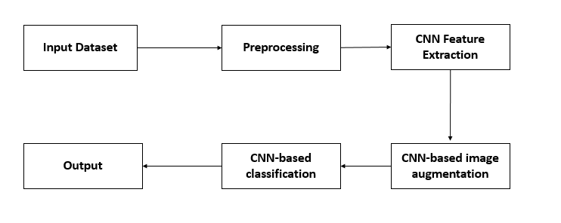

**CNN Feature Extraction**

**CNN-based image augmentation**

CNN-based classification

**Fig 5.3 SYSTEM ARCHITECTURE**

**5.4 PROPOSED ARCHITECTURE**

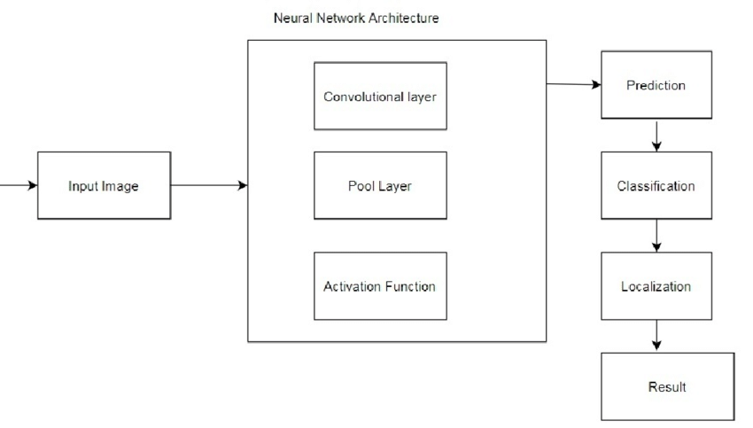

**Fig 5.4 PROPOSED ARCHITECTURE**

22

**CHAPTER-6**

**6.SYSTEM IMPLEMENTAION**

System implementation in brain tumor detection refers to the practical realization of the designed solution. It involves translating the conceptual design into a functional system that can effectively detect brain tumors.

**6.1 DATA COLLECTION AND PREPARATION**

* Gather a dataset of brain images, including MRI , with corresponding labels indicating tumor regions.
* Preprocess the data by resizing images, normalizing pixel intensities, and ensuring consistent formatting.

**6.2 DEVELOPMENT ENVIRONMENT SETUP**

* Set up the development environment with the required software, libraries, and frameworks for image processing and machine learning.
* Choose a programming language such as Python and select appropriate libraries like OpenCV, TensorFlow, or PyTorch.

**6.3 DATA PREPROCESSING**

* Apply preprocessing techniques to enhance the quality and suitability of the input data.
* Perform noise reduction, image enhancement, and normalization to standardize the data for analysis.

**6.4 FEATURE EXTRACTION**

23

* Implement feature extraction algorithms or utilize pre-trained models to extract relevant features from the brain images.
* Apply image processing techniques such as edge detection, texture analysis, or deep learning-based feature extraction.

**6.5 MODEL DEVELPOMENT**

* Select a suitable machine learning or deep learning algorithm for brain tumor detection, such as CNNs or SVMs.
* Split the preprocessed data into training and testing sets.
* Train the selected model using the training set and optimize it using appropriate optimization algorithms and techniques.

**6.6 VISUALIZATION AND INTERPRETATION**

* Develop visualizations and user interfaces to display the results of tumor detection.
* Overlay detected tumor regions on the original images or generate heatmaps indicating the probability or confidence of tumor presence.
* Provide tools for clinicians or radiologists to interpret and validate the results.

**6.7 TESTING AND VALIDATION**

* Conduct thorough testing to validate the accuracy, reliability, and performance of the implemented system.
* Test the system with different datasets and compare the results against ground truth or expert annotations.

**6.8 MAINTENANCE AND IMPROVEMENT**

* Regularly maintain and update the system to address any issues, bugs, or performance bottlenecks.

24

**CHAPTER-7**

**7 TESTING**

Testing in brain tumor detection refers to the process of evaluating the performance and accuracy of a brain tumor detection system or algorithm. It is a crucial step in ensuring that the system can effectively identify and classify tumor regions in brain images.

**7.1 TEST DATASET**

Selecting a representative and diverse dataset of brain images is essential for testing. The dataset should include a mix of tumor and non-tumor images, covering different types, sizes, and locations of tumors. The dataset should be sufficiently large and balanced to ensure comprehensive testing.

**7.2 PERFORMANCE METRICS**

Define appropriate performance metrics to evaluate the system's performance. Common metrics used in brain tumor detection include accuracy, sensitivity, specificity, precision, recall, F1 score, and area under the receiver operating characteristic (ROC) curve. These metrics provide quantitative measures of the system's ability to correctly identify tumors and distinguish them from non-tumor regions.

**7.3 VALIDATION AGAINST GROUND TRUTH**

Compare the system's results against ground truth or expert annotations to determine its accuracy. This involves comparing the system's detected

25

tumor regions with the known tumor regions in the test dataset.Validation helps assess the system's ability to correctly identify tumor boundaries and distinguish them from healthy brain tissue.

**7.4 CROSS-VALIDATION**

Utilize cross-validation techniques to assess the system's generalization performance. This involves dividing the dataset into multiple subsets, training the system on one subset, and testing it on the remaining subsets. Cross-validation helps evaluate the system's ability to perform consistently across different subsets of data and mitigate the effects of dataset bias.

**7.5 ROBUSTNESS TESTING**

Evaluate the system's robustness by testing it with variations in input data. This can include assessing its performance with different imaging modalities, varying image resolutions, or introducing noise or artifacts to simulate real-world scenarios. Robustness testing helps ensure that the system can handle different types of input data and still provide accurate tumor detection.

**7.6 COMPARATIVE ANALYSIS**

Compare the performance of the developed system with existing methods or alternative algorithms. This can involve benchmarking against established approaches or comparing against the performance of other state-of-the-art brain tumor detection systems. Comparative analysis helps determine the effectiveness and advancement of the developed system.

26

**CHAPTER-8**

**8 CONCLUSION**

In conclusion, the development of a brain tumor detection system holds significant promise in improving the diagnosis and treatment of brain tumors. Through the utilization of advanced techniques such as machine learning, deep learning, and image processing, accurate and automated detection of brain tumors has become achievable. The existing system demonstrates its potential in accurately identifying tumor regions, aiding healthcare professionals in making informed decisions and providing timely treatment.

In conclusion, brain tumor detection is an active area of research with significant potential for improving patient care. Continuous advancements in algorithms, data availability, and computational capabilities will drive further enhancements in accuracy, efficiency, and clinical adoption. Future work in this field has the potential to revolutionize brain tumor diagnosis, treatment, and patient outcomes.

**8.1 FUTURE WORK**

While the current system has shown promising results, there are several avenues for future work and improvements in brain tumor detection. Some potential areas of focus include enhanced Accuracy, Robustness and Generalization, Clinical Validation and Incorporating Advanced Analytics.

27

**CHAPTER-9**

**9 APPENDIX I - SOURCE CODE**

**9.1 CODING**

**from flask import make_response,Flask, flash, redirect, render_template, request, url_for, session**

**from app import \***

**import re**

**import numpy as np**

**import os**

**from tensorflow.keras import models**

**from tensorflow.keras.models import load_model**

**from tensorflow.keras.preprocessing import image**

**from tensorflow.python.ops.gen_array_ops import concat**

**from tensorflow.keras.applications.inception_v3 import preprocess_input**

**import requests**

**import PIL**

**from PIL import Image**

**model = load_model(r'Model/model.h5')**

**@app.route('/')**

**def home():**

**return render_template('index.html')**

28

**@app.route('/precautions')**

**def precautions():**

**return render_template('precautions.html')**

**@app.route('/upload', methods=['GET'])**

**def UploadGet():**

**return render_template('upload.html')**

**@app.route('/upload', methods=['POST'])**

**def UploadPost():**

**print('!!')**

**file = request.files['file']**

**if file.filename == '' :**

**flash('No image selected for uploading')**

**return redirect(request.url)**

**else:**

**file.save(file.filename)**

**img = image.load_img(file.filename,target_size = (299,299))**

**x = image.img_to_array(img)**

**x=np.expand_dims(x,axis=0)**

**img_data = preprocess_input(x)**

**precaution = np.argmax(model.predict(img_data),axis=1)**

29

**label = ['pituitary_tumor','meningioma_tumor','No tumor','glioma_tumor']**

**result = str(label[precaution[0]])**

**return render_template('upload.html',result=result)**

**9.2 FLASK CODING**

**import os**

**import sys**

**from flask import Flask**

**STATIC_FOLDER = sys.path[0] + '/static/'**

**TEMPLATES_FOLDER = sys.path[0] + '/templates/'**

**app = Flask(__name__, template_folder=TEMPLATES_FOLDER, static_folder=STATIC_FOLDER)**

30

**CHAPTER-10**

**10 APPENDIX-2**

**10.1 SCREENSHOTS**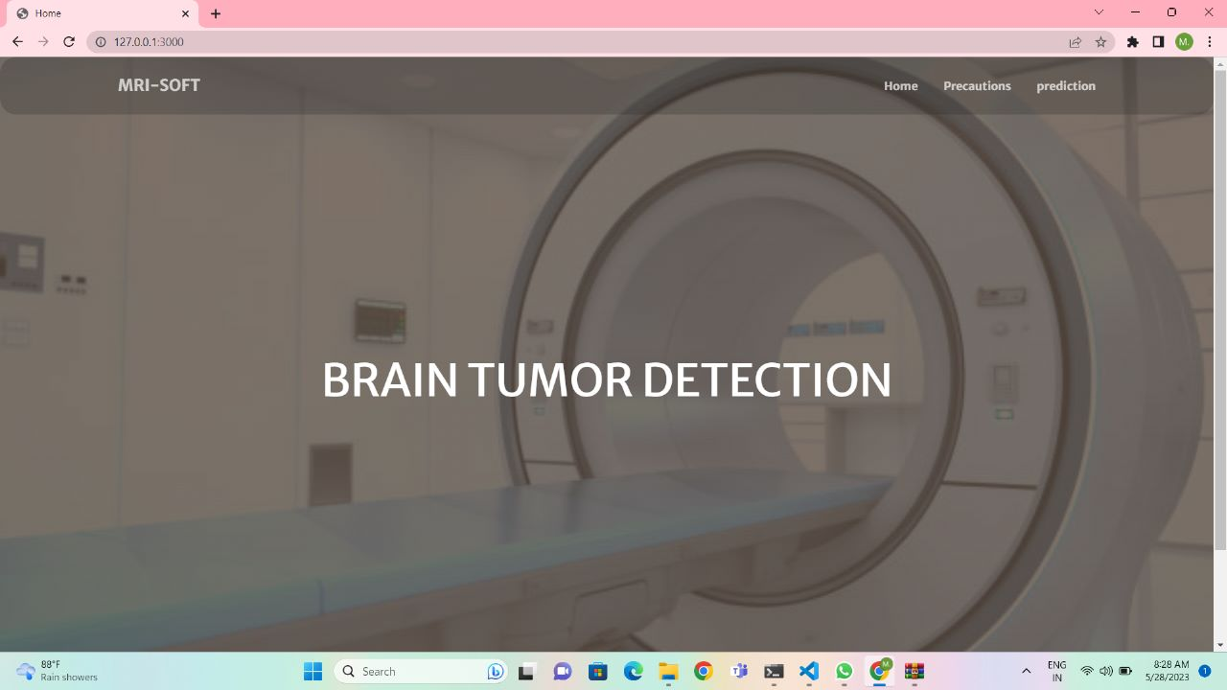

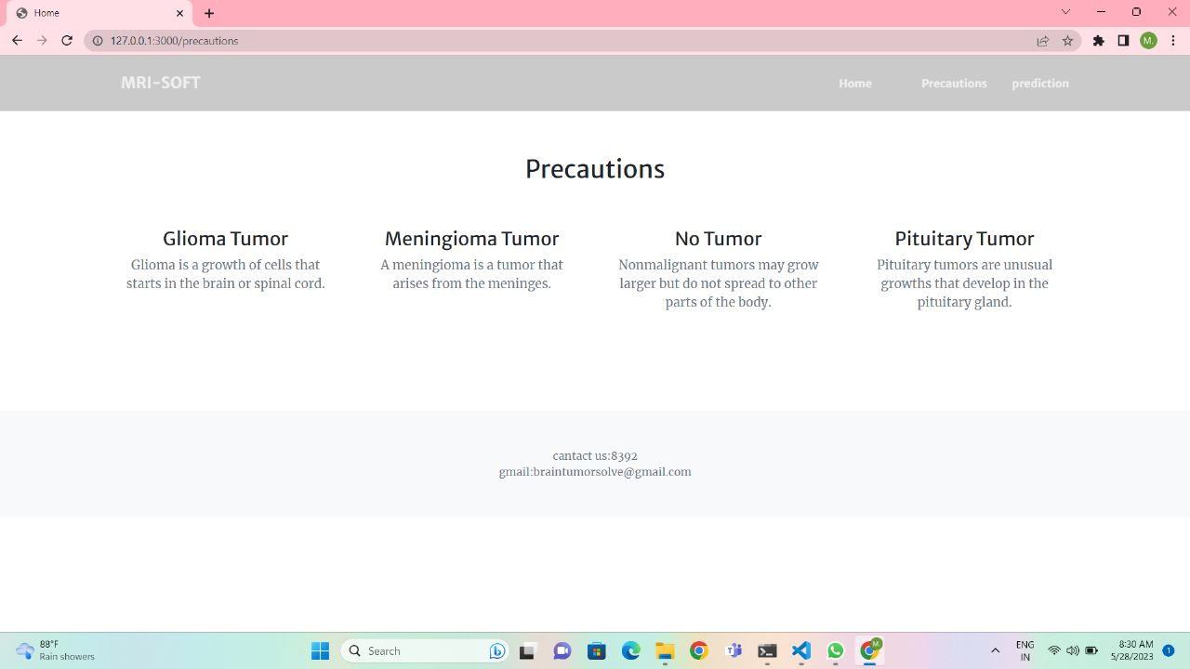 31

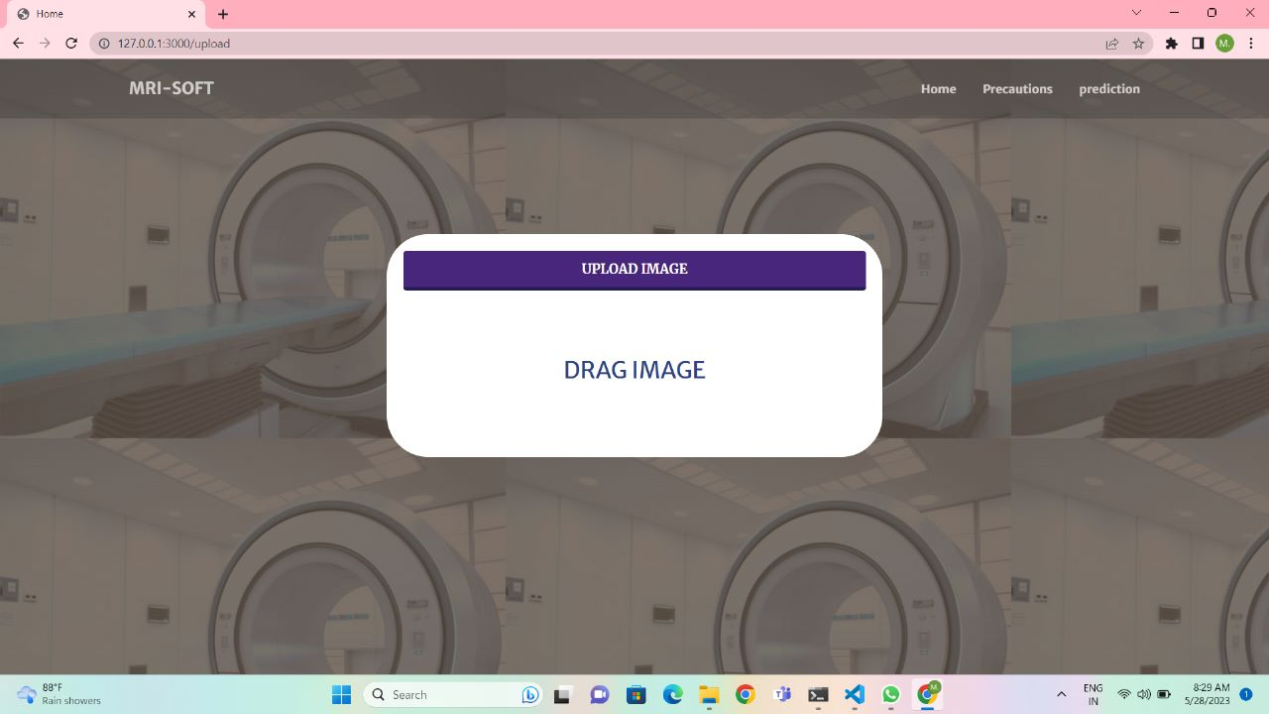

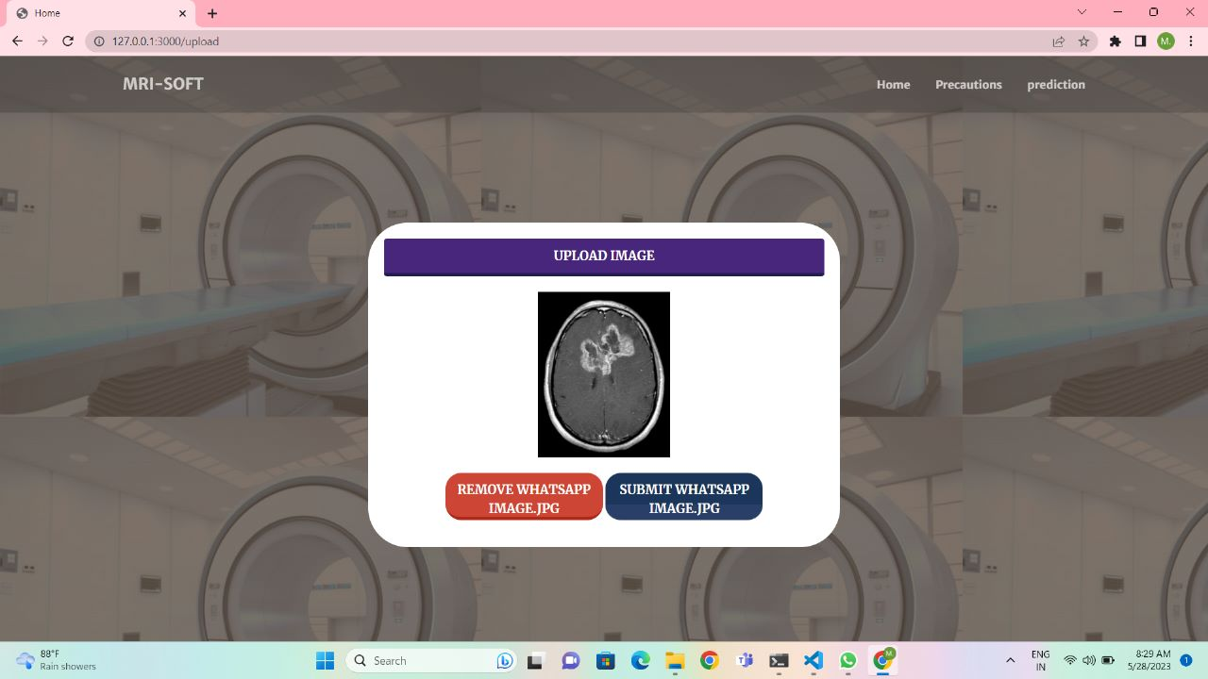  32

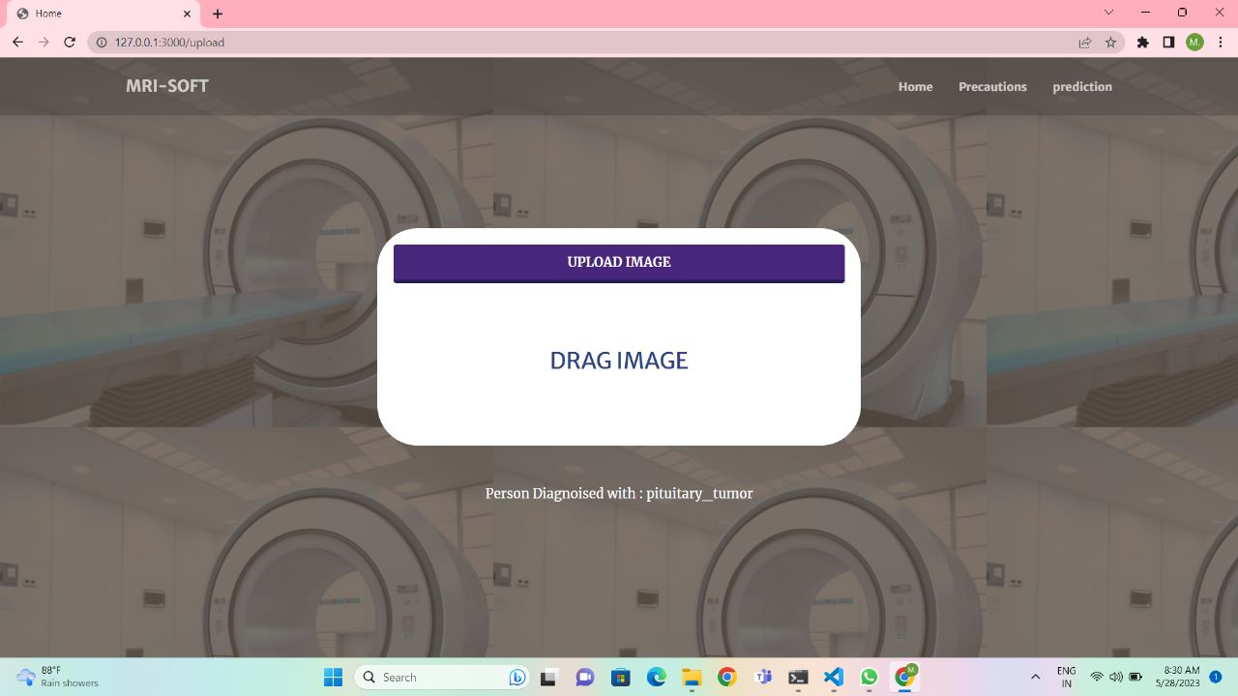

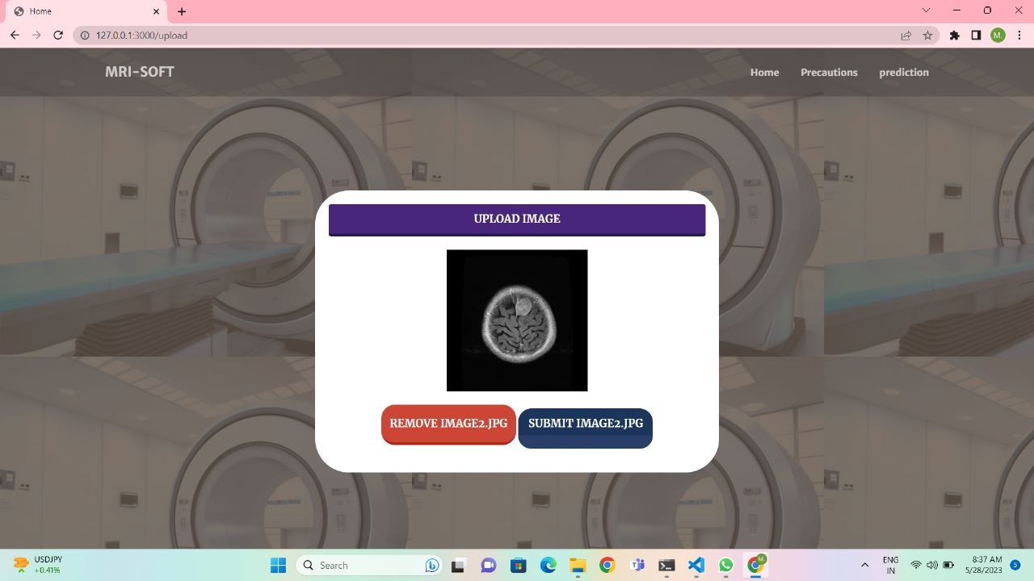 33

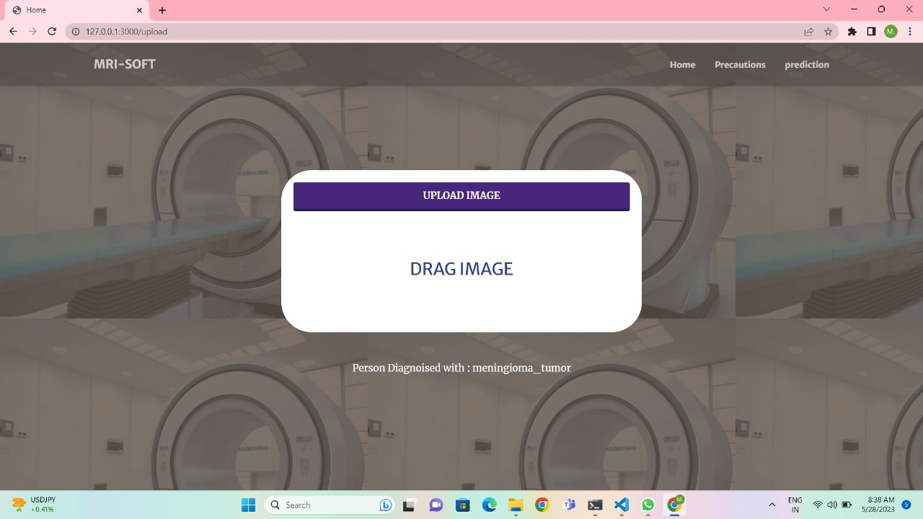

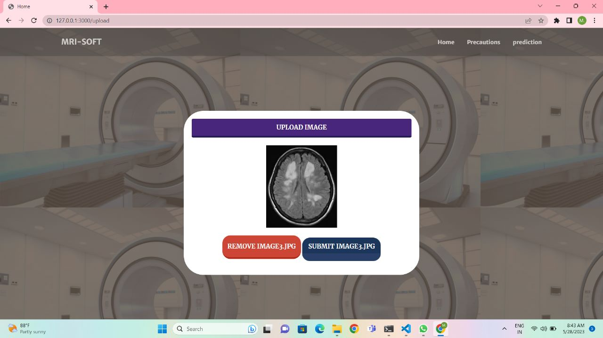 34

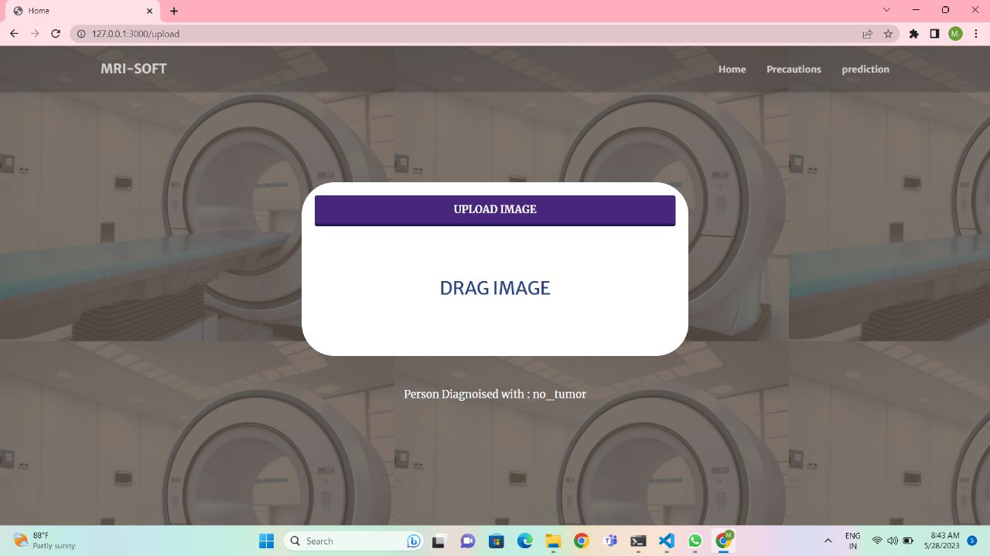

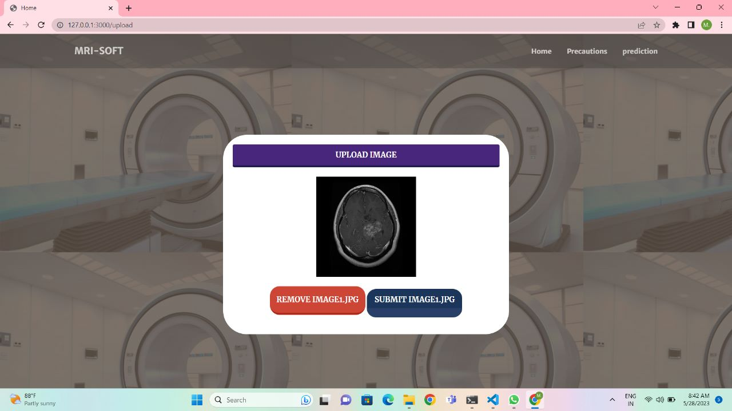 35

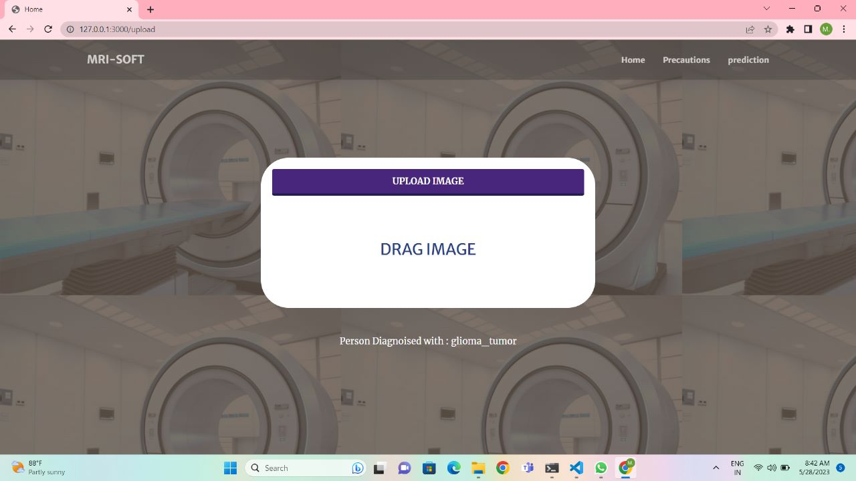

36

**CHAPTER-11**

**11 APPENDIX-3**

**11.1REFERENCES**

* Anis Ben Aissa published "Brain Tumor Detection and Classification Using Convolutional Neural Networks" in the International Journal of Advanced Computer Science and Applications in 2020.
* S. R. Azimi published "Deep Learning for Brain Tumor Detection and Segmentation: A Review" in the IEEE Access Journal in 2020.
* Shivang Aggarwal published "A Review of Deep Learning Applications in Brain Tumor Detection Using Magnetic Resonance Imaging" in the Journal of Healthcare Engineering in 2020.
* Sudhir Kumar Sharma published "Deep Learning-Based Automatic Detection of Brain Tumor Using MRI Images: A Systematic Review" in the Journal of Digital Imaging in 2021.

37